**疫情旅游意愿模型报告**

**一、描述性分析**

（注：方案一与方案二的描述性分析一样，数据来源与方案一）

**单维构念因子载荷**

|  |  |  |  |
| --- | --- | --- | --- |
| 变量名称 | 观测值代号 | 因子载荷 | P值 |
| Variable A | A1 | 0.829 | 0.018 |
| A2 | 0.788 | 0.017 |
| A3 | 0.856 | 0.019 |
| Variable B | B1 | 0.811 | 0.240 |
| B2 | 0.799 | 0.243 |
| B3 | 0.849 | 0.239 |
| Variable C | C1 | 0.435 | 0.029 |
| C2 | 0.916 | 0.054 |
| C3 | 0.871 | 0.069 |
| Variable D | D1 | 0.868 | 0.010 |
| D2 | 0.750 | 0.074 |
| D3 | 0.717 | 0.044 |
| Trust government | E1 | 0.815 | 0.000 |
| E2 | 0.634 | 0.000 |
| E3 | 0.856 | 0.000 |
| Trust epidemic | F1 | 0.760 | 0.000 |
| F2 | 0.761 | 0.000 |
| F3 | 0.847 | 0.000 |
| Affective Response | G1 | 0.795 | 0.000 |
| G2 | 0.872 | 0.000 |
| G3 | 0.588 | 0.000 |
| Social Norm | H1 | 0.870 | 0.000 |
| H2 | 0.787 | 0.000 |
| H3 | 0.841 | 0.000 |
| Travel intention | K1 | 1.000 |  |
| Variable L | L1 | 0.798 | 0.000 |
| L2 | 0.854 | 0.000 |
| L3 | 0.812 | 0.000 |
| L4 | 0.754 | 0.000 |
| Variable M | M1 | 0.612 | 0.000 |
| M2 | 0.570 | 0.000 |
| M3 | 0.847 | 0.000 |
| M4 | 0.753 | 0.000 |

**二维构念因子载荷**

|  |  |  |  |
| --- | --- | --- | --- |
| 变量名称 | 观测值代号 | 因子载荷 | P值 |
| Psychological isolation | A1 | 0.705 | 0.065 |
| A2 | 0.629 | 0.068 |
| A3 | 0.724 | 0.064 |
| B1 | -0.472 | 0.324 |
| B2 | -0.404 | 0.385 |
| B3 | -0.490 |  |
| Physical isolation | C1 | 0.464 | 0.018 |
| C2 | 0.728 | 0.051 |
| C3 | 0.695 | 0.068 |
| D1 | 0.716 | 0.002 |
| D2 | 0.400 | 0.240 |
| D3 | 0.459 | 0.083 |
| Preventive behavior intention | L1 | 0.739 | 0.000 |
| L2 | 0.765 | 0.000 |
| L3 | 0.729 | 0.000 |
| L4 | 0.692 | 0.000 |
| M1 | 0.539 | 0.000 |
| M2 | 0.427 | 0.000 |
| M3 | 0.678 | 0.000 |
| M4 | 0.622 | 0.000 |

**变量信度和效度**

|  |  |  |  |  |
| --- | --- | --- | --- | --- |
| **变量** | **Cronbach's Alpha** | **组合信度CR** | **平均抽取变异量(AVE)** | **P值** |
| Affective Response | 0.668 | 0.801 | 0.579 | 0.000 |
| Physical isolation | 0.626 | 0.755 | 0.352 | 0.000 |
| Preventive behavior intention | 0.806 | 0.856 | 0.433 | 0.000 |
| Psychological isolation | 0.608 | 0.108 | 0.340 | 0.000 |
| Social Norm | 0.783 | 0.872 | 0.695 | 0.000 |
| Trust epidemic | 0.699 | 0.833 | 0.625 | 0.000 |
| Trust government | 0.675 | 0.816 | 0.600 | 0.000 |
| Variable A | 0.765 | 0.864 | 0.680 | 0.000 |
| Variable B | 0.757 | 0.860 | 0.672 | 0.000 |
| Variable C | 0.605 | 0.802 | 0.595 | 0.000 |
| Variable D | 0.691 | 0.823 | 0.610 | 0.000 |
| Variable L | 0.819 | 0.881 | 0.649 | 0.000 |
| Variable M | 0.653 | 0.793 | 0.496 | 0.000 |

注：Note: α = Cronbach’s alpha; AVE = Average variance extracted; CR = Composite reliability.

只有所有构念Cronbach α﹥0.7，组合信度﹥0.7，每个构架的平均方差提取（AVE）≥0.55，才提供了内部一致性信度和收敛效度的证据。

**二、路径分析**

**注：**

出游计划赋值

|  |  |  |
| --- | --- | --- |
|  | 实际 | 复值 |
| 没有旅行计划 | 1 | 1 |
| 有旅游计划并全部实施了 | 2 | 4 |
| 有旅游计划并部分实施了 | 3 | 3 |
| 有旅游计划但是都没有实施 | 4 | 2 |

**1、模型图**

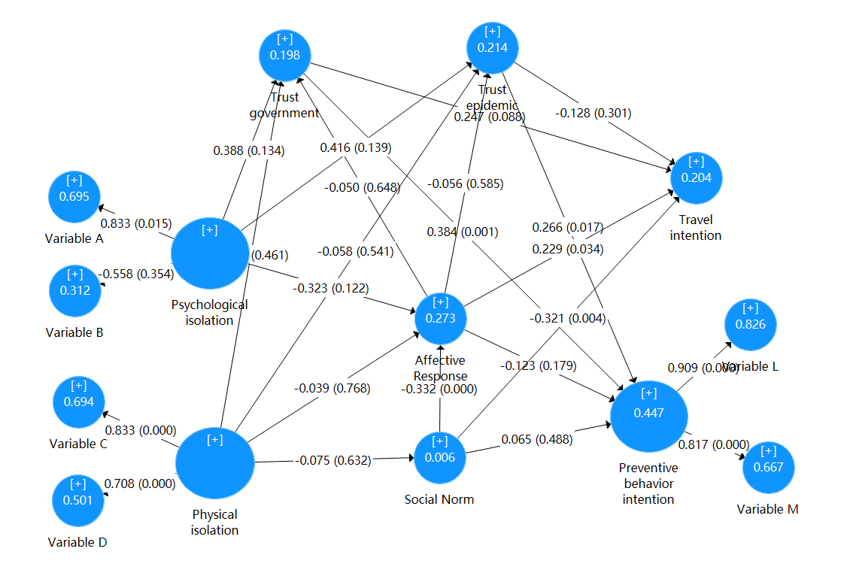

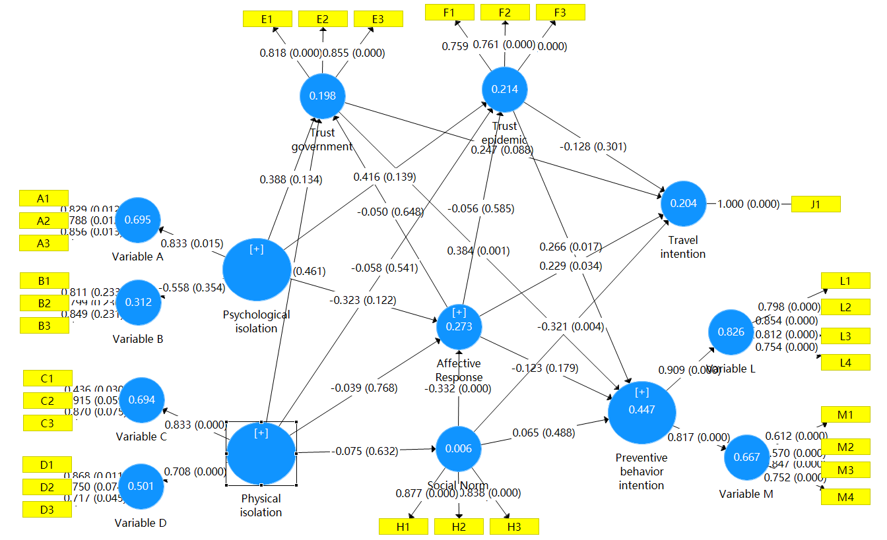

**2、路径系数表**

（注：40个单路径有12个显著，标绿的显著）

|  |  |  |  |
| --- | --- | --- | --- |
|  | 初始样本 (O) | T统计量 | P值 |
| Affective Response -> Preventive behavior intention | -0.123 | 1.343 | 0.179 |
| Affective Response -> Travel intention | 0.229 | 2.120 | 0.034 |
| Affective Response -> Trust epidemic | -0.056 | 0.547 | 0.585 |
| Affective Response -> Trust government | -0.050 | 0.457 | 0.648 |
| Physical isolation -> Affective Response | -0.039 | 0.295 | 0.768 |
| Physical isolation -> Social Norm | -0.075 | 0.480 | 0.632 |
| Physical isolation -> Trust epidemic | -0.058 | 0.611 | 0.541 |
| Physical isolation -> Trust government | -0.083 | 0.737 | 0.461 |
| Physical isolation -> Variable C | 0.833 | 9.246 | 0.000 |
| Physical isolation -> Variable D | 0.708 | 5.884 | 0.000 |
| Preventive behavior intention -> Variable L | 0.909 | 33.134 | 0.000 |
| Preventive behavior intention -> Variable M | 0.817 | 13.421 | 0.000 |
| Psychological isolation -> Affective Response | -0.323 | 1.547 | 0.122 |
| Psychological isolation -> Trust epidemic | 0.416 | 1.481 | 0.139 |
| Psychological isolation -> Trust government | 0.388 | 1.498 | 0.134 |
| Psychological isolation -> Variable A | 0.833 | 2.435 | 0.015 |
| Psychological isolation -> Variable B | -0.558 | 0.927 | 0.354 |
| Social Norm -> Affective Response | -0.332 | 3.595 | 0.000 |
| Social Norm -> Preventive behavior intention | 0.065 | 0.694 | 0.488 |
| Social Norm -> Travel intention | -0.321 | 2.871 | 0.004 |
| Trust epidemic -> Preventive behavior intention | 0.266 | 2.388 | 0.017 |
| Trust epidemic -> Travel intention | -0.128 | 1.035 | 0.301 |
| Trust government -> Preventive behavior intention | 0.384 | 3.362 | 0.001 |
| Trust government -> Travel intention | 0.247 | 1.706 | **0.088** |

注：样本量115，置信区间95% ，5000次Bootstrap抽样。显著性水平：*** p < .001. ** p < .01. * p < .05。

**3、调整后R方**

|  |  |  |  |
| --- | --- | --- | --- |
| 变量 | 调整后R方 | T统计量 | P值 |
| Affective Response | 0.276 | 3.025 | 0.002 |
| Preventive behavior intention | 0.449 | 4.302 | 0.000 |
| Social Norm | 0.005 | 0.147 | 0.884 |
| Travel planning | 0.218 | 2.880 | 0.004 |
| Trust epidemic | 0.215 | 1.931 | 0.054 |
| Trust government | 0.198 | 2.044 | 0.041 |
| Variable A | 0.697 | 3.918 | 0.000 |
| Variable B | 0.310 | 1.548 | 0.122 |
| Variable C | 0.695 | 5.048 | 0.000 |
| Variable D | 0.500 | 3.121 | 0.002 |
| Variable L | 0.826 | 17.120 | 0.000 |
| Variable M | 0.667 | 7.309 | 0.000 |